

High Level Design
Prepared by: Daniel Robledo Munoz | 10 February 2026

An Post – AWS Landing Zone



Contents

1. Document overview 5
1.1. Project Background 5
1.2. PAD application overview 5
1.3. An Open Data Portal with downloads and API facilities 6
1.4. Document Purpose 7
1.5. Workload-Dependent Design Decisions 7

2. Solution Overview 8
2.1. What is an AWS Landing Zone? 8
2.2. Logical Architecture in a Landing Zone 8
2.3. Organizational Units 9
2.4. AWS Landing Zone – Core Accounts 10
2.5. AWS Services by Landing Zone Account 11
2.6. Primary Services in a AWS Landing Zone 11
2.7. Multi-Account Architecture 13
2.7.1. PAD Architecture 13
2.7.2. Eircode Open Data Portal Architecture 16

3. Deployment approach 17
3.1. Landing Zone Accelerator (LZA) 17
3.2. Landing Zone Accelerator – Config Files 17
3.3. Landing Zone Accelerator – Deployment 18
3.4. Account Factory for Terraform (AFT) 18
3.5. AFT Repositories 19
3.6. Account Factory for Terraform – Deployment 20

4. Security 21
4.1. IAM Identity Center 21
4.1.1. SSO Login Page 21
4.1.2. Root Identities 21
4.1.3. Securing Root Identities 22

5. Cost Management 23
5.1. Consolidated Billing 24

Version Control
Date | Version | Changed By | Reason for Change
10/2/2026 | 0.1 | Daniel Robledo Munoz | Initial draft
18/2/2026 | 1.0 | Daniel Robledo Munoz | First version to publish An Post

Circulation List
Name | Organisation/Title
Karl Coffey | An Post / Chief Enterprise Architect
Paul Hanover | Version 1 / Delivery Manager
Gerry Whelan | Version 1 / Enterprise Architect
Daniel Robledo Munoz | Version 1 / Cloud Architect
Shubham Narandekar | Version 1 / DevOps Engineer

Reference Documents
Title | Description | Owner
TBC | TBC | TBC

Document overview

Project Background

Capita had been hosting the PAD database, which was accessed by Autoaddress through a dedicated VPN connection. Following Capita’s withdrawal from the project, An Post has decided to assume full ownership of the platform by migrating the PAD database into a newly established AWS Landing Zone within its own environment. This engagement with An Post focuses on designing and implementing this AWS Landing Zone to accommodate the infrastructure previously managed by Capita. In addition, the new environment must incorporate the necessary endpoints that support the downloading of ECAD and ECAF files, ensuring continuity of service within the consolidated AWS new ecosystem.

Following Capita’s exit from Eircode operations, An Post Eircode requires a newly established AWS Landing Zone to support:​
- PAD application for operations in producing Eircodes​
- An Open Data Portal with downloads and API facilities ​
- The Eircode.ie site (TBC)

PAD application overview

PAD is a two-component application suite that supports both automated, long-running data processing and interactive, user-driven administration, with all persistence centralized in AWS RDS for SQL Server. The solution is designed so that the database is the single source of truth, and both applications reuse a common backend logic and data-access layer.
Core components
- Data Processing App (batch / automation):
A Windows-based processing application used for long-running jobs that combine C# logic and SQL Server stored procedures. It may be executed from a user PC or a jump-box depending on operational constraints.
- Interactive Web App (operations / monthly admin):
A map-centric web application used by the maintenance team to perform monthly administrative updates. The front end is Angular, hosted on IIS, with a .NET REST API backend.
- Database layer (shared):
The solution uses a shared database layer, where all PAD data is stored in an RDS SQL Server instance accessed by both applications through a common data access layer built on Entity Framework. The database is confirmed to be dedicated rather than multi-tenant. Operationally, the dataset currently occupies approximately 2 TB—including headroom—and grows at around 40 GB per month, with archiving incorporated into the regular maintenance process.

Based on the information provided by Autoaddress, PAD has the following non-functional requirements: a security posture built on network isolation, least-privilege access, encryption at rest, and the assurance that no PII is processed. The platform must run in private subnets with controlled administrative access. Availability expectations include defining whether Multi-AZ is required and documenting any single points of failure. Backup and recovery are mandatory, with automated RDS backups (30-day retention) and an RTO/RPO of 24 hours, supported by periodic restore testing. Performance and capacity planning should use the current 2 TB database footprint and ~40 GB monthly growth as a baseline. Connectivity must follow the existing model of VPN ingress and SFTP file transfer, with DB snapshot sharing used for environment transitions. Observability requires centralized logging and full auditability through CloudTrail, RDS logs, and VPC flow logs. Finally, maintainability relies on version-controlled database migrations (Flyway) and governed release processes with appropriate approvals.

An Open Data Portal with downloads and API facilities

The new Amazon Web Services (AWS) Landing Zone must provide a capability that allows any customer to openly and securely download two published datasets—Eircode Address Files (ECAF) and Eircode Address Database (ECAD)—via a simple public link exposed on a web page (for example, a “Download” button). The user experience must be straightforward: a customer clicks the link and receives the requested dataset download without needing to sign in or register, in line with Ireland’s implementation of the Open Data Directive, which promotes open-by-default data and easy access for re-use.
The datasets to be downloaded are distributed as compressed files with the following approximate sizes:
- ECAF: ~300 KB
- ECAD: ~367 MB
The objective is therefore to deliver a reliable, secure, and scalable download capability within the AWS Landing Zone that supports public access to these two files for any customer through an open link, consistent with Ireland’s Open Data Directive principles on availability and re-use.

Document Purpose

This document provides a high-level design and overarching architectural view of the An Post AWS Landing Zone solution, including its core components. The Landing Zone provides the foundational architecture for securely hosting workloads in AWS, aligned with the AWS Well-Architected Framework (WAF). This architectural assessment evaluates the future implementation against six core pillars: Security, Operational Excellence, Reliability, Performance Efficiency, Cost Optimization and Sustainability. The primary objective of this exercise is to identify areas for improvement, identify security vulnerabilities, and evaluate the long-term viability of both the application and its underlying platform.

The review surfaces several critical gaps spanning all six AWS WAF pillars. While some of these findings were specific to the application's immediate architecture and have since been addressed, a significant portion highlighted a broader lack of platform-level competency and consistent governance. The implementation of an AWS Landing Zone is proposed as the strategic solution to address and resolve these fundamental shortcomings, thereby establishing a more secure and scalable cloud foundation.

Workload-Dependent Design Decisions

When navigating this document, please refer to the hand icon placed throughout. This icon indicates design decisions that are intentionally left open at this High-Level Design (HLD) stage, as they are dependent upon the onboarding of specific workloads and their individual requirements. These pending decisions will be addressed during the application onboarding phase to ensure alignment with application specific requirements.

Solution Overview

What is an AWS Landing Zone?

An AWS Landing Zone is a standardized, secure, and automated foundation for deploying cloud workloads: a pre-configured AWS environment that sets up a governed multi-account structure with baseline security, networking, logging, and compliance guardrails aligned to the AWS Well-Architected Framework. Built using services such as AWS Organizations, AWS Control Tower, and AWS Config—often complemented by automation and infrastructure-as-code—it enables consistent configuration, centralized visibility, and scalable governance across the entire AWS environment.

Logical architecture in a Landing Zone

A Landing Zone is structured into three layers: Management, Core, and Workload accounts.

These three layers enforce separation of duties and reduce the blast radius of incidents and misconfigurations. The Management account centralizes governance and lifecycle controls for the Landing Zone; Core accounts host shared security, logging, and network services run by platform teams, centralizing cross-account visibility and controls while reducing cost by reusing common platform components that would otherwise be duplicated in every workload; Workload accounts isolate applications and environments for safe autonomy.
For An Post, this architecture improves security and audit readiness, simplifies operations through standardised guardrails and central logging, enables faster onboarding of new initiatives, and provides clearer cost ownership per workload—while maintaining high availability for critical services.

The diagram below illustrates a logical architecture of the AWS Landing Zone with respect to the personas – Administrators, Platform Engineers and Developers - that operate at each layer: Management, Operations & Application Development.

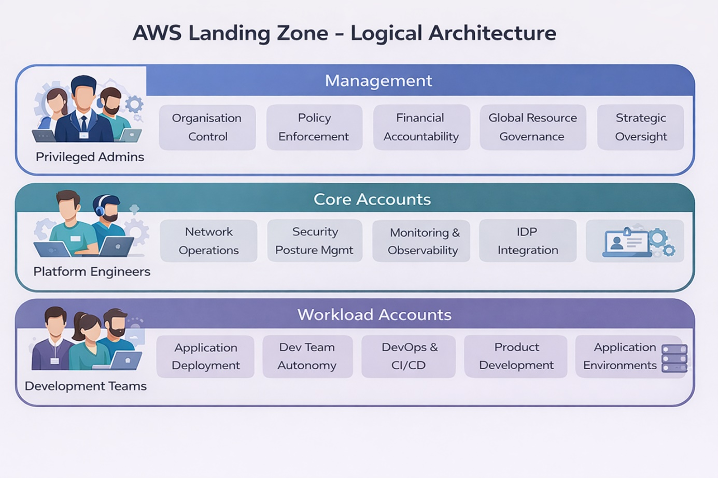
Figure 1 AWS Landing Zone – Multi-account Architecture

Organizational Units

An Organizational Unit (OU) in AWS is a logical container used to group AWS accounts within AWS Organizations and arrange them into a hierarchical structure. This hierarchy enables consistent governance at scale by allowing controls to be applied to whole groups of accounts rather than managing each account individually.

The main purpose of OUs is to simplify management and strengthen governance across the AWS environment by applying shared policies and guardrails to all accounts within a given OU. This is especially effective when combined with Service Control Policies (SCPs), which set the maximum allowable permissions for accounts in the OU—providing a clear boundary for what actions are permitted regardless of the permissions assigned inside individual accounts.

The table below describes the OUs deployed as part of the Landing Zone solution.

OU | Layer | Role
Root | Management | The top-level Organisational Unit, primarily containing the AWS Organisations Management account. It serves as the administrative root for the entire multi-account environment, hosting core services that manage and govern the organisation.
Security | Core | Dedicated to centralising security services and controls. It houses accounts for security auditing (i.e., Log Archive & Audit) and incident response, ensuring compliance monitoring and unified security posture across the organisation.
Infrastructure | Core | Designed to host shared infrastructure accounts (e.g., Network, Shared Services). This OU contains resources and services that are common dependencies for multiple workloads and are managed centrally, such as Transit Gateways, shared VPCs, or (potentially) directory services.
Workloads | Workload | A logical grouping that serves as a parent container for accounts hosting application and service environments. It provides a hierarchical structure to organise various Sandbox, Test, and Production deployments.
Production | Workload | Contains AWS accounts specifically allocated for live, mission-critical application deployments. This OU is subject to the most stringent security, operational, and change management controls to ensure stability and compliance for Production workloads.
Non-Production | Workload | Houses AWS accounts designated for development, testing, staging, and quality assurance environments. Controls here are typically more relaxed than in Production, allowing for agility in development while still maintaining a secure baseline.
Sandbox | Workload | Provides isolated AWS accounts for experimental development, proof-of-concept work, and learning. These accounts offer a high degree of autonomy to users (Developers and Engineers) but are typically subject to strict cost controls and are isolated from production environments.

AWS Landing Zone – Core Accounts

The following table describes the primary AWS accounts deployed as part of the Landing Zone solution.

Account / ID | OU | Role
Management /  Acc. Id | N/A | This is the primary account of the AWS Organisation and the central point for billing, Service Control Policies (SCPs), and overall management of other AWS accounts. This account hosts the core Landing Zone Accelerator pipeline and automation services (CodePipeline, CodeBuild, Lambda functions) responsible for vending and governing new accounts (via AWS Control Tower’s Account Factory service), as well as managing the organisational structure.
Audit /  Acc. id | Security | A highly restricted, dedicated account for centralising all security and compliance-related logs and resources. This includes consolidating AWS Config recordings, GuardDuty findings, Security Hub aggregates, and other security service outputs from all accounts across the organisation. Access to this account is limited to security and compliance personnel only.  It also integrates with AWS IAM Identity Center (formerly SSO) for centralised access management.
Log Archive /  Acc. Id | Security | A dedicated account for long-term, immutable storage of all organisational and operational logs. This includes CloudTrail logs, S3 access logs and VPC Flow Logs. Its primary purpose is secure, centralised, and immutable log retention for compliance, auditing, and troubleshooting.
Network /  Acc. Id | Infrastructure | Dedicated for centralising network infrastructure that spans multiple accounts across the entire organisation. This includes AWS Transit Gateway (for inter-VPC routing), centralised egress points, and shared DNS services. Consolidating networking here simplifies management and enhances security.

AWS Services by Landing Zone Account

In the Management account, you typically place the organization-level controls: AWS Organizations administration, account vending/provisioning, baseline guardrails, and centralized policy management, because these functions must govern all accounts and should be tightly controlled with limited access. It’s the “Command center for the Landing Zone governance”: it defines standards, enforces them consistently, and reduces configuration drift across workloads.
The Core accounts run the shared “runway” services operated by platform teams, such as centralized logging/audit trails, security monitoring and incident response tooling, network/shared connectivity services, and shared CI/CD or tooling where applicable. These are separated into different core accounts to isolate risk and privileges: for example, a dedicated Log Archive account prevents tampering with evidence, while a Security account can monitor everything without granting broad write access elsewhere. A separate Network/Connectivity account (or equivalent) protects routing, shared egress/ingress, and connectivity constructs from application-level changes and reduces blast radius. This separation also supports segregation of duties, clearer operational ownership, and easier auditing, while allowing each core domain to scale and evolve independently without impacting others.

Primary Services in a AWS Landing Zone
The following table describes the primary AWS services deployed as part of the Landing Zone solution.

Service | Account | Function
AWS Control Tower | Management | AWS Control Tower builds on AWS Organisations to set up and govern a secure, multi-account AWS environment i.e. the Landing Zone, according to best practices. It automates the setup of the platform’s core accounts (Management, Log Archive and Audit accounts), configures guardrails (both preventative and detective), and provides a dashboard for continuous monitoring and compliance. It acts as an orchestration layer for many underlying AWS services.
AWS Organizations | Management | AWS Organizations provides the structure for a governed multi-account Landing Zone by grouping accounts into OUs and enforcing guardrails with SCPs. It centralizes billing and cost visibility across the estate. It also supports delegated administration so core teams can operate security and compliance services centrally.
AWS Identity Center (SSO) | Management | Centralises access management to all accounts within the AWS Organisation. It enables single sign-on access to AWS accounts and any applications using an existing corporate directory (e.g., Active Directory) or its own managed directory. It defines permissions at a centralised level and propagates them across the various member accounts via permission sets.
AWS IAM | Management | Defines and enforces permissions through roles and policies across every account. It enables least-privilege access for humans (via federated roles/permission sets) and service-to-service access for workloads (execution roles). It also supports secure cross-account access patterns used by platform, security, and operations teams
AWS GuardDuty | Audit | Provides continuous threat detection across accounts by analyzing signals like CloudTrail activity, VPC Flow Logs, DNS logs, and other supported sources. It generates prioritized security findings for suspicious behavior (e.g., credential compromise, reconnaissance, anomalous access, malware-related indicators). When run with delegated administration, it enables centralized detection and response across all workload accounts while keeping workloads isolated.
AWS Security Hub | Audit | AWS Security Hub centralizes and normalizes security findings from AWS services and third-party tools into a single view across your accounts. It continuously evaluates security posture against standards (e.g., CIS, AWS Foundational Security Best Practices) and highlights misconfigurations.
AWS CloudTrail | Log Archive | Records and retains API activity and console actions across your AWS accounts, providing an auditable history of who did what, when, and from where. In a Landing Zone, it’s typically enabled org-wide and centralized to support security investigations, compliance, and change tracking.
AWS CloudWatch | Log Archive | Collects and visualizes metrics, logs, and events from AWS resources and applications to provide operational visibility.  It enables alerting via alarms (e.g., latency, errors, capacity) and supports troubleshooting through log analytics and dashboards.  In a Landing Zone, it helps standardize monitoring across accounts and centralize critical telemetry for operations.
AWS Transit Gateway | Network | AWS Transit Gateway is the central network hub that connects VPCs across multiple Landing Zone accounts (and often on-prem) using a scalable hub-and-spoke model. It replaces complex VPC peering with standardized attachments and centralized routing control. Its route tables enable network segmentation and governance so only approved account/VPC paths can communicate.
AWS Billing and Cost Management | Management? | Provides consolidated billing, cost allocation, and spend visibility across all accounts, with tools like Cost Explorer, Budgets, and Cost and Usage Reports. It supports forecasting, anomaly detection, and budget alerts to control and optimize cloud spend.  Because the management (payer) account is highly sensitive, it’s often not best practice to grant broad access there—many organizations restrict it to finance and a small admin set and provide read-only cost views via tightly scoped roles or reporting outputs.

Multi-account Architecture

Based on the information and requirements provided for hosting these two applications, the AWS Landing Zone for An Post is designed as a hierarchical, multi-account environment aligned to AWS best practices for governance, security, networking, and workload isolation.
The diagram below illustrates this multi-account Landing Zone architecture and its account hierarchy, including the Organisational Units deployed as part of this engagement.
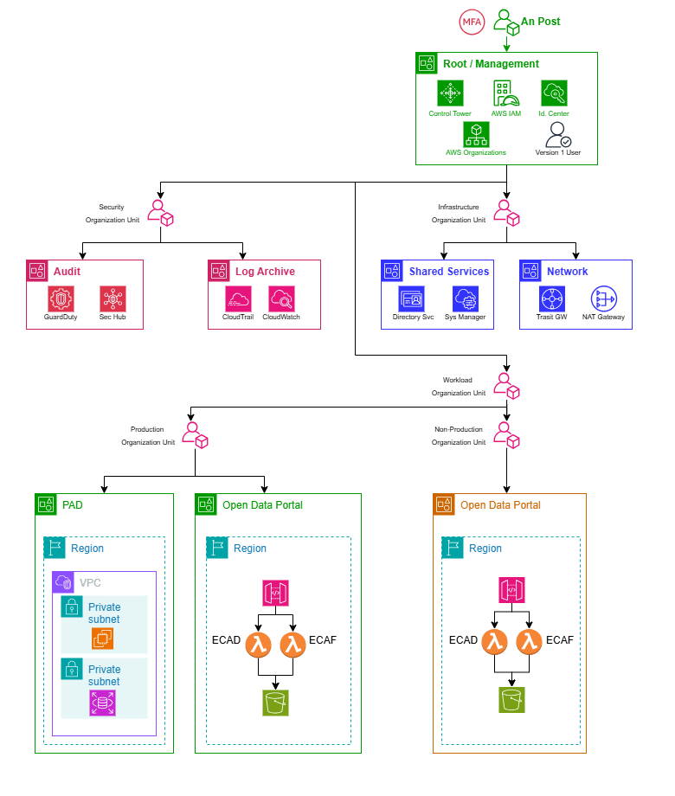

Figure 2 AWS Landing Zone - Account Hierarchy

PAD Architecture

This architecture satisfies the core PAD hosting and operational requirements by deploying the PAD solution within a secure, governed, multi-account AWS Landing Zone that separates shared services, security monitoring, centralized logging, networking, and the PAD workload itself. The Shared Services Account provides identity services (including Identity Center and AWS Managed Microsoft AD if required), the Audit Account provides centralized threat and security posture services (GuardDuty and Security Hub), and the Log Archive Account centralizes monitoring and log storage (CloudWatch and S3). This separation supports governance, auditability, and operational control in line with the PAD non-functional requirements.

The PAD workload is hosted in a dedicated PAD Account and PAD VPC, where the Interactive App and Data Processing App run in private subnets and connect to an Amazon RDS for SQL Server instance deployed privately in the same VPC. The database tier is shown with a primary RDS instance and a standby instance across two Availability Zones, which supports resilience and availability requirements for PAD operations. This design provides a secure and robust runtime platform for the PAD solution, including the 25 production databases and associated stored procedures and scripts used by the Eircode maintenance process.

Secure remote access for the Autoaddress operator team is provided through AWS Client VPN in the Ingress VPC of the Network Account, with authentication integrated through SAML/SSO and MFA (via Identity Center). Operators connect from their laptops to the Client VPN endpoint and are routed privately through the central Transit Gateway into the PAD VPC. From there, operators can use SQL Server Management Studio (SSMS) and the PAD applications without exposing the PAD environment or the RDS SQL Server instance to the public internet. In this model, Identity Center and SSO control user authentication and VPN access, while database authorization is enforced separately within SQL Server using SQL users, roles, and permissions aligned to operator job roles.

The Transit Gateway, hosted centrally in the Network Account and shared to the PAD Account using AWS Resource Access Manager (RAM), provides the private connectivity backbone between the Ingress VPC, Egress VPC, and the PAD workload VPC. This supports a clean hub-and-spoke network model within the Landing Zone and allows the PAD account to remain isolated while still consuming centrally managed ingress and egress capabilities.

The Egress VPC includes the Internet Gateway and NAT Gateway to provide controlled outbound internet access where required. This remains necessary for workloads that need internet egress (for example, approved external services or operating system updates). At the same time, the PAD VPC includes VPC Endpoints (PrivateLink and S3 Gateway Endpoint) so that core AWS service traffic remains private and does not depend on NAT. The endpoints shown for SSM, EC2Messages, SSMMessages, CloudWatch Logs, and Secrets Manager support secure administrative operations and service integration within the PAD VPC, while the S3 Gateway Endpoint provides private access to S3 for PAD-related exports or workflow integrations where applicable. Together, this combination of VPC Endpoints and NAT Gateway strengthens the security posture while preserving operational flexibility.
The architecture also includes AWS Systems Manager (Session Manager) as a secure administration path for the PAD application EC2 instances (Interactive App and Data Processing App). Session Manager is included to support administration, maintenance, patching, and troubleshooting of the EC2-based application tier without opening inbound management ports such as SSH or RDP. This is an Admin/Ops path only and is intentionally separate from the operator access path. PAD operators continue to access the PAD solution and database services through the Client VPN and SSMS, while administrators use Session Manager for controlled EC2 management.

To support operational non-functional requirements, the design includes CloudWatch alarms and RDS Enhanced Monitoring for observability, AWS Backup policy and RDS backup/snapshot capabilities for recovery, KMS for encryption of RDS, S3, and Secrets Manager data, and Secrets Manager for secure storage of application and database credentials. These controls collectively support PAD requirements for security, monitoring, backup, and operational maintainability.

Finally, the migration requirement from the existing CAPITA-hosted environment is represented through a dedicated migration path using AWS DMS or backup/restore, explicitly marked as dependent on the export method CAPITA can provide. This is the correct implementation-ready representation because it avoids assuming a direct snapshot transfer approach before the source handover process is confirmed. The optional snapshot export to S3 is also shown as a separate capability for export or archival use cases and is not treated as the default RDS backup mechanism.

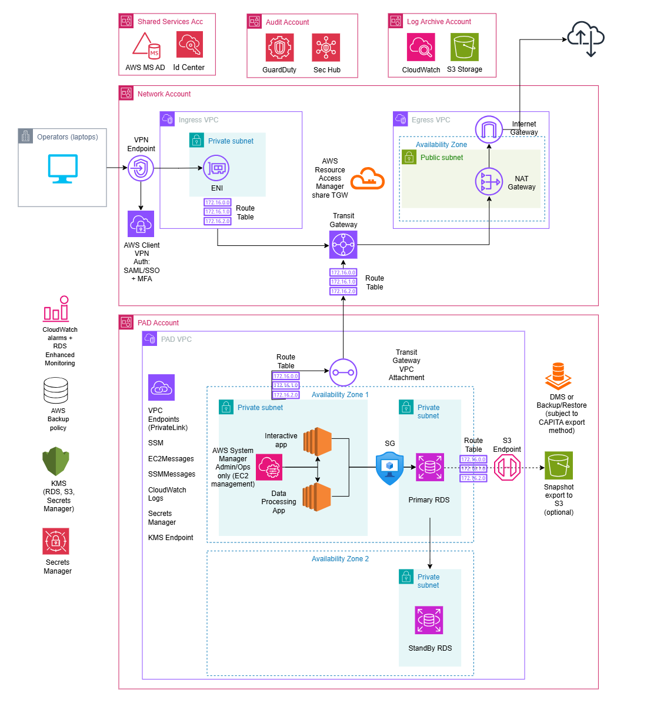

Eircode Open Data Portal Architecture

This Open Data Portal architecture is aligned with the HLD because it implements the public ECAD/ECAF release capability as a separate workload in a dedicated Open Data Portal Account, while reusing the shared Landing Zone governance accounts (Shared Services, Audit, and Log Archive). This follows the HLD’s segregation and security approach, keeping the public download service isolated from the PAD operational environment.

The public access path is correctly designed as User → AWS WAF → API Gateway → Lambda (ECAF / ECAD) → S3 Releases Bucket. API Gateway provides the controlled HTTPS entry point, the two Lambda functions implement the download logic for each data product type, and the S3 bucket stores the published ECAD/ECAF release files. This directly supports the requirement to provide an appointed Open Data Portal location for ECAD and ECAF releases.

AWS WAF is justified because the endpoint is publicly exposed, even if access is regional. It provides baseline protection (managed rules), rate limiting, and optional geo restrictions, which supports the HLD’s security and internet exposure control principles. KMS is included to enforce encryption at rest for the S3 releases bucket, in line with the HLD’s encryption requirements.

CloudWatch Logs and CloudWatch Alarms support the non-functional requirements for monitoring and operations by providing logging, visibility, and alerting for API Gateway and Lambda activity. The diagram also correctly includes Admins / Release Operators via Identity Center + MFA, which reflects the HLD requirement for federated access, least privilege, and secure administration of AWS resources.

Finally, the shared Audit Account (GuardDuty, Security Hub) and Log Archive Account (CloudWatch/S3 centralized logging) remain relevant for this serverless workload, ensuring that the Open Data Portal is operated under the same centralized security and audit controls as the rest of the platform. Overall, this is a valid, secure, and HLD-aligned design for the Open Data Eircode application.

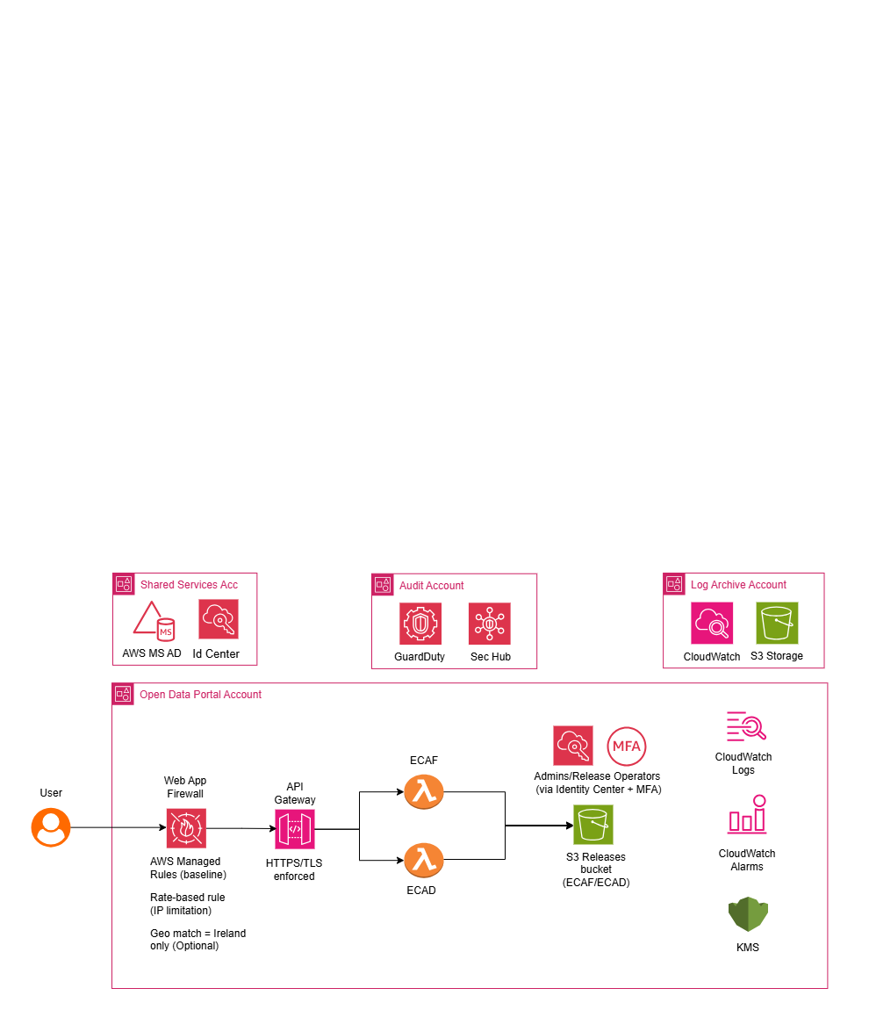

Deployment approach

Landing Zone Accelerator (LZA)

The AWS Landing Zone Accelerator (LZA) is an open-source solution designed to automate the rapid deployment of a secure, scalable, and compliant multi-account AWS environment. Built upon AWS best practices and aligning with various global compliance frameworks, LZA leverages Infrastructure as Code (IaC) principles through AWS Cloud Development Kit (CDK) and a set of YAML configuration files.
It extends the foundational capabilities of AWS Control Tower by providing enhanced customisation for security controls, network topology centralised logging, auditing, and automated account provisioning. This significantly reduces the upfront manual effort in establishing a cloud foundation, enabling An Post to accelerate their cloud adoption while maintaining strict governance and security posture.

Landing Zone Accelerator – Config Files

At the heart of the AWS Landing Zone Accelerator solution are six YAML configuration files: accounts-config.yaml, global-config.yaml, iam-config.yaml, network-config.yaml, organisation-config.yaml, and security-config.yaml. These declarative files serve as the primary interface for An Post to define and customise the desired multi-account AWS environment.Therefore, the solution warrants a dedicated GitHub repository to version control these configuration files. The table below captures the GitHub repo and link to same.

Repo Name | GitHub Link
ap_aws_landing_zone_configuration | TBC

Landing Zone Accelerator – Deployment

The diagram below illustrates a high-level overview of how the An Post managed Landing Zone Configuration repository relates to the AWS components that comprise the Landing Zone solution.

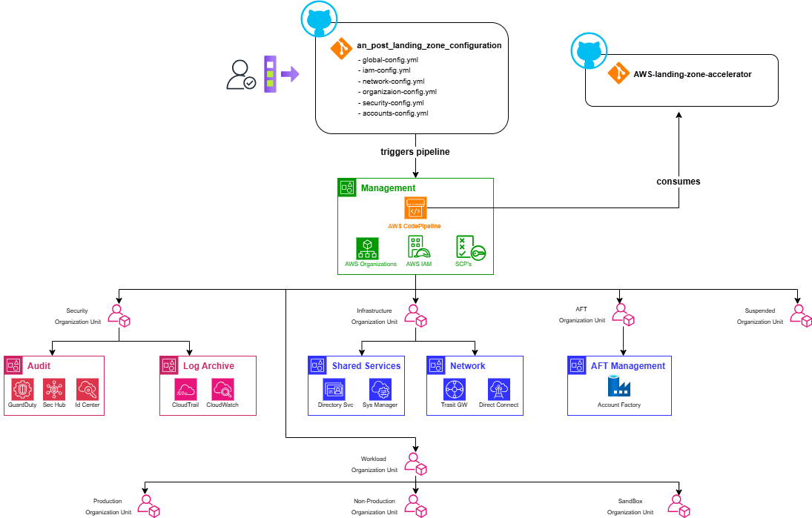

Figure 3 Landing Zone Accelerator - Deployment

Account Factory for Terraform (AFT)

While the AWS Landing Zone Accelerator (LZA) focuses on deploying a comprehensive, compliant multi-account baseline, Account Factory for Terraform (AFT) serves a distinct, complementary purpose.

AFT is an open-source solution built on top of AWS Control Tower that specifically leverages Terraform (HashiCorp’s IaC tool) to automate the provisioning and customisation of individual AWS accounts. Unlike LZA, which establishes the overarching foundational infrastructure and governance of the Landing Zone itself using AWS CDK and YAML configurations, AFT provides a GitOps-driven pipeline for self-service account vending, enabling An Post’s Cloud Platform team to procure new, pre-configured accounts in compliance with established guardrails.

This distinction means the LZA builds the foundation, while AFT provides the automated "factory" to rapidly spin up new accounts within the established foundational structure, offering greater flexibility for teams who prefer Terraform for their infrastructure deployments.

Account Factory for Terraform (AFT) offers distinct advantages beyond merely supporting Terraform-proficient teams:
- AFT mitigates operational risk by separating the provisioning of individual member accounts from the broader landing zone deployment.
- Smaller Blast Radius:
  - The AWS Landing Zone Accelerator (LZA) relies on a highly complex CodePipeline instance to manage the entire multi-account environment. A misconfiguration or issue within the LZA's core pipeline could have a wide-ranging, detrimental impact across the entire AWS Organization.
  - In contrast, AFT's pipelines are specifically focused on vending and customising individual member accounts. A misconfiguration within an AFT process is scoped primarily to the specific account(s) affected, significantly limiting the potential "blast radius" to individual member accounts rather than the foundational Landing Zone itself.
- AFT provides a more agile and resilient workflow for routine account creation, reducing the need to frequently interact with or re-execute the more complex and comprehensive LZA pipeline for this specific task.

AFT Repositories

Repo Name | GitHub Link
<TBC>_aws_lz_aft_account_request | https://github.com/<repository_name>/ <TBC>_aws_lz_aft_account_request
<TBC>_aws_lz_aft_global_customizations | https://github.com/<repository_name>/  <TBC>_aws_lz_aft_global_customizations
<TBC>_aws_lz_aft_account_  provisioning_customizations | https://github.com/<repository_name>/ <TBC>_aws_lz_aft_account_provisioning_customizations
<TBC>_aws_lz_aft_account_customizations | https://github.com/<repository_name>/ <TBC>_aws_lz_aft_account_customizations
<TBC>_aws_account_factory_vending | https://github.com/<repository_name>/  <TBC>_aws_account_factory_vending

Account Factory for Terraform – Deployment

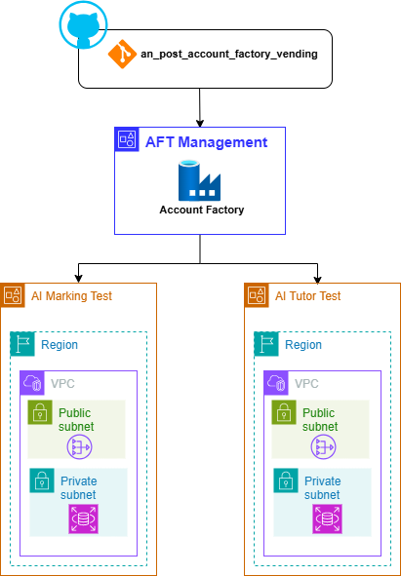

Figure 4 AFT - Deployment

Security

IAM Identity Center

IAM Identity Center (formerly AWS Single Sign-On) will be leveraged to provide a streamlined and secure method for managing access across the multi-account AWS environment.
- The Landing Zone Accelerator creates an IAM Identity Center instance in the AWS Management account. This service facilitates Single-Sign On for all AWS users which is especially pertinent when working in a multi-account structure. The introduction of this service negates the need to create and manage separate IAM users in each individual account, significantly reducing administrative overhead.
- It facilitates a seamless Single Sign-On experience for all AWS users. Users log in once to a central user portal with their credentials and can then securely access all assigned AWS accounts and roles without re-authenticating.
- When new users are created an invitation process guides them through password setup and mandatory Multi-Factor Authentication (MFA) configuration. This ensures a standardised, secure, and automated onboarding experience. Conversely, centralised management simplifies rapid offboarding and access revocation.
- Access to AWS accounts is managed through Permission Sets. These define specific AWS IAM policies and permissions (e.g., Administrator Access, Read-Only, Developer Access) that are then assigned to users or groups. IAM Identity Center automatically provisions and manages corresponding IAM roles in each target AWS account, ensuring consistent application of the principle of least privilege across your organisation.
- The management of new identities, existing identities and associated permissions is all managed under IAM Identity Center console.


For the initial Landing Zone implementation, IAM Identity Center will be configured to provide Single Sign-On (SSO) capabilities across all member accounts within the AWS Organisation, with users managed directly within Identity Center's own directory. The primary purpose at this stage is to centralise user access and streamline login to AWS accounts. This baseline configuration does not include integration with external Identity Providers (IdP) or the development of custom IAM roles via Identity Center.

SSO Login Page
The table below captures the SSO login page for accessing the various AWS accounts deployed as part of the Landing Zone.

Description | Link
An Post AWS LZ SSO Landing Page | https://<TBC>

Root Identities

When a new AWS account is created, whether it's a standalone account or part of an AWS Organization, a unique root user identity tied to an email address is a mandatory requirement to complete the process. For An Post’s AWS Landing Zone, all of the core Platform AWS accounts will leverage the "plus addressing" feature of the Management account's email address.
This strategy ensures that the root user email for every core Platform AWS account adheres to a consistent and easily identifiable naming convention:
<management_account_email>+<AWS_Account Name>@anpost.ie. For example, since the Management account's email is <TBC>@anpost.ie, the root user email associated with the Landing Zone’s Network account is <TBC>+network@anpost.ie.
Similarly, the root user email associated with the Log Archive AWS account is <TBC>+logarchive@anpost.ie.
This method offers several benefits for managing a multi-account AWS environment:
- All root user emails for various accounts route to a single, controlled inbox associated with the Management account. This simplifies monitoring and significantly reduces the administrative overhead of managing separate mailboxes for each account.
- By centralizing email reception, it becomes easier to secure the primary email inbox, thereby safeguarding the recovery mechanism for all root users across the organization. This reduces the attack surface compared to scattering root user emails across multiple, potentially less secure, individual mailboxes.
- In the event of a lost root user password or compromised credentials for any member account, the password reset emails are delivered to the designated Management account inbox, facilitating a quicker and more controlled recovery process.
- Having a consistent and predictable naming pattern for root user emails aids in auditing and tracking account ownership and communication.


For all workload AWS accounts deployed to the Landing Zone, a new Shared mailbox will be generated to mitigate against any security compromises relating to the Shared mailbox configured on the Platform level AWS accounts i.e. anpostaws@anpost.ie, providing a layer of demarcation between workload and Platform level AWS accounts.

For AWS accounts deployed via the Platform config repository e.g. Network account, Audit account:
- An SSO Identity is automatically generated for each account, except for the Audit and LogArchive accounts. These two accounts only have a root user email address; they do not get an SSO identity.

For AWS accounts deployed via the Account Factory for Terraform (AFT) managed repository:

- Both a root user identity and an SSO root user identity are generated.
- This dual identity approach significantly enhances security by minimizing direct root user logins. Instead, users can access the new AWS account via an automatically generated IAM Identity Center user, which aligns with AWS best practices. This automated creation streamlines access, saves time, and provides the flexibility for distinct email addresses for the root and SSO users.

AWS Account | Root User Identity | SSO Identity
Management | apaws@anpost.ie | apaws@anpost.ie
Audit | apaws+audit@anpost.ie | N/A
Log Archive | apaws+logarchive@anpost.ie | N/A
Network | apaws+networking@anpost.ie | apaws+networking@anpost.ie
Shared S. | apaws+ss@anpost.ie | apaws+ss@anpost.ie

Securing Root Identities

While the root user of each AWS account in the Landing Zone should be used sparingly, securing the root email address and its associated identity is crucial for maintaining the overall security posture and ensuring a recovery mechanism for the multi-account environment. This email address serves as the primary recovery point for the account's root user credentials, making its compromise a critical threat that could lead to unauthorised access and control over AWS resources.
To achieve robust security for these critical root email identities, a standard process should be rigorously followed for each new account provisioned within the Landing Zone:
- Accept invitation: Upon account creation and its invitation to the AWS Organisation, the root user associated with the unique email must accept the invitation. This involves a first-time login to the AWS Management Console for that specific account e.g. apawslz+network@anpost.ie
- Initial login: After the initial login, the default or temporary password must be immediately changed to a strong, complex, and unique password. This new password should never be shared verbally or stored insecurely.
- Securely store password: The new password for each account's root user must be stored securely in an enterprise-grade password manager.
- MFA: Multiple MFA devices (e.g., multiple virtual MFA applications on different trusted individuals' phones) should be registered to each root user. This redundancy ensures that if one device is lost or inaccessible, there are still alternative authorised MFA devices to regain access.
- Shared Mailbox: The use of "plus addressing" (e.g., apawslz+network@anpost.ie) routes all root user emails to a designated, shared mailbox (i.e., apawslz@anpost.ie). This centralises the receipt of critical notifications for all accounts.
- Forwarding Rules: (Optional, but recommended) To mitigate the risk of important emails being lost or unread in a shared mailbox that might not be frequently checked, configure automated forwarding rules. These rules should forward all incoming emails from the root email addresses to a distribution list of relevant administrators (e.g., a DL containing Vik, Matt, Craig & Stuart) or integrate with a centralised alerting system (e.g., Microsoft Teams). This ensures that critical alerts are pushed to the relevant personnel's personal inboxes or collaborative channels, requiring no explicit action to "check" the shared mailbox and dramatically reducing the chance of missing vital communications.

Cost Management

Consolidated Billing
The consolidated billing feature in AWS Organisations consolidates billing and payment for multiple AWS accounts. The AWS Management account is responsible for paying the charges of all member accounts.
Consolidated billing has the following benefits:
- One bill – You get one bill for multiple accounts in the same Source of Record. If an organization has accounts from multiple SORs, you receive one bill per SOR.
- Easy tracking – You can track the charges across multiple accounts and download the combined cost and usage data.
- Combined usage – You can combine the usage across all accounts in the organization to share the volume pricing discounts, Reserved Instance discounts, and Savings Plans. This can result in a lower charge for your project, department, or company than with individual standalone accounts.
- No extra fee – Consolidated billing is offered at no additional cost.
- You can see a combined view of the AWS charges that the member accounts incur. You also can generate a cost report for each member account.


For more information,
please visit version1.com
Thank you

